**PRACTICUM OVERALL PERSONAL REFLECTION**

|  |  |
| --- | --- |
| Student Name | **MICLAT, CHADLE REI M.** |
| Section | **WD-401** |
| Personal Email Address | **cmmiclatyo@gmail.com** |
| LinkedIn Link | **https://www.linkedin.com/in/chadle-rei-miclat-557a16293/** |
| Name of Immediate Supervisor | **John Anthony Almario** |
| Title/Position | **Web Development Intern** |
| Email Address | **cmmiclat@student.hau.edu.ph** |

**Clark Outsourcing**

Clark Outsourcing is an American owned and operated business process outsourcing company strategically located in the heart of the Clark Freeport Zone in the Philippines. The goal is to help small and mid-sized companies leverage their business by offering the global resources that were previously only available to the Fortune 500 companies. Located in the Clark Freeport Zone of the Philippines, we are in the right place at the right time to help facilitate your next BPO project. Our CEO Zack Williamson, has been serving small, mid-sized firms in the United States, India, Romania, South Africa and Philippines since 2006. We maintain a state of the art infrastructure complete with racks of server, fiber optic lines, multiple carriers and redundant backup systems. Its mission is to bring the world of outsourcing resources that were previously only available to large firms and the Fortune 500, to small and mid-sized companies. We will deliver success by providing highly driven people who will treat their business as their own and other business inputs that promote continuous improvement to achieve maximum competitiveness. The company’s executive team starts with Zack Williamson as the CEO and Co-founder, Russell Meiselman as President and Co-founder, Edward Lacandola as Vice President and Shareholder, Rica Licer CHantengco as AVP - People Management and Shareholder, and Noriel Bueno as FInance Director and Shareholder.

**Roles and Responsibilities** (in paragraph form)

Our roles/responsibilities involved a learning process. Our supervisors gave us chances to learn how to do Angular programming. They had us participate in a f2f meeting, teaching us many things, as well as assigning a project. The project involves making a website solely for self learning. Later, we had a company project involving Jira software, this served as our final project that the staff will utilize as a system. The employees in my department start with Mr. John Anthony Almario who serves as the web development lead of the team. Meanwhile other members include Gabriel Castro, Kyle Ryan Austria, Rowen Mark Pangilinan, Christopher Neil Gomez, Jan Deniel Bondoc, Aldrin Macatangay, Jonah Velasquez.

**An Evaluation of my Training**

The work environment takes place in a warehouse-like building complete with an individual computer for every person. For us interns, we used Linux Ubuntu systems. The workplace is very friendly and free, anyone can take a break any time they want, as long as tasks and objectives are completed within deadlines. I learned from our supervisors and seniors all about Angular development as well as the usage of Jira software to create a ticketing system. The only challenge that we had was our work areas were far from the supervisors/seniors, hence, we can’t ask questions or advice easily. I personally prefer to work alone so I can work at my own pace and understand my code much better to proceed at a much more consistent and predictable pace.

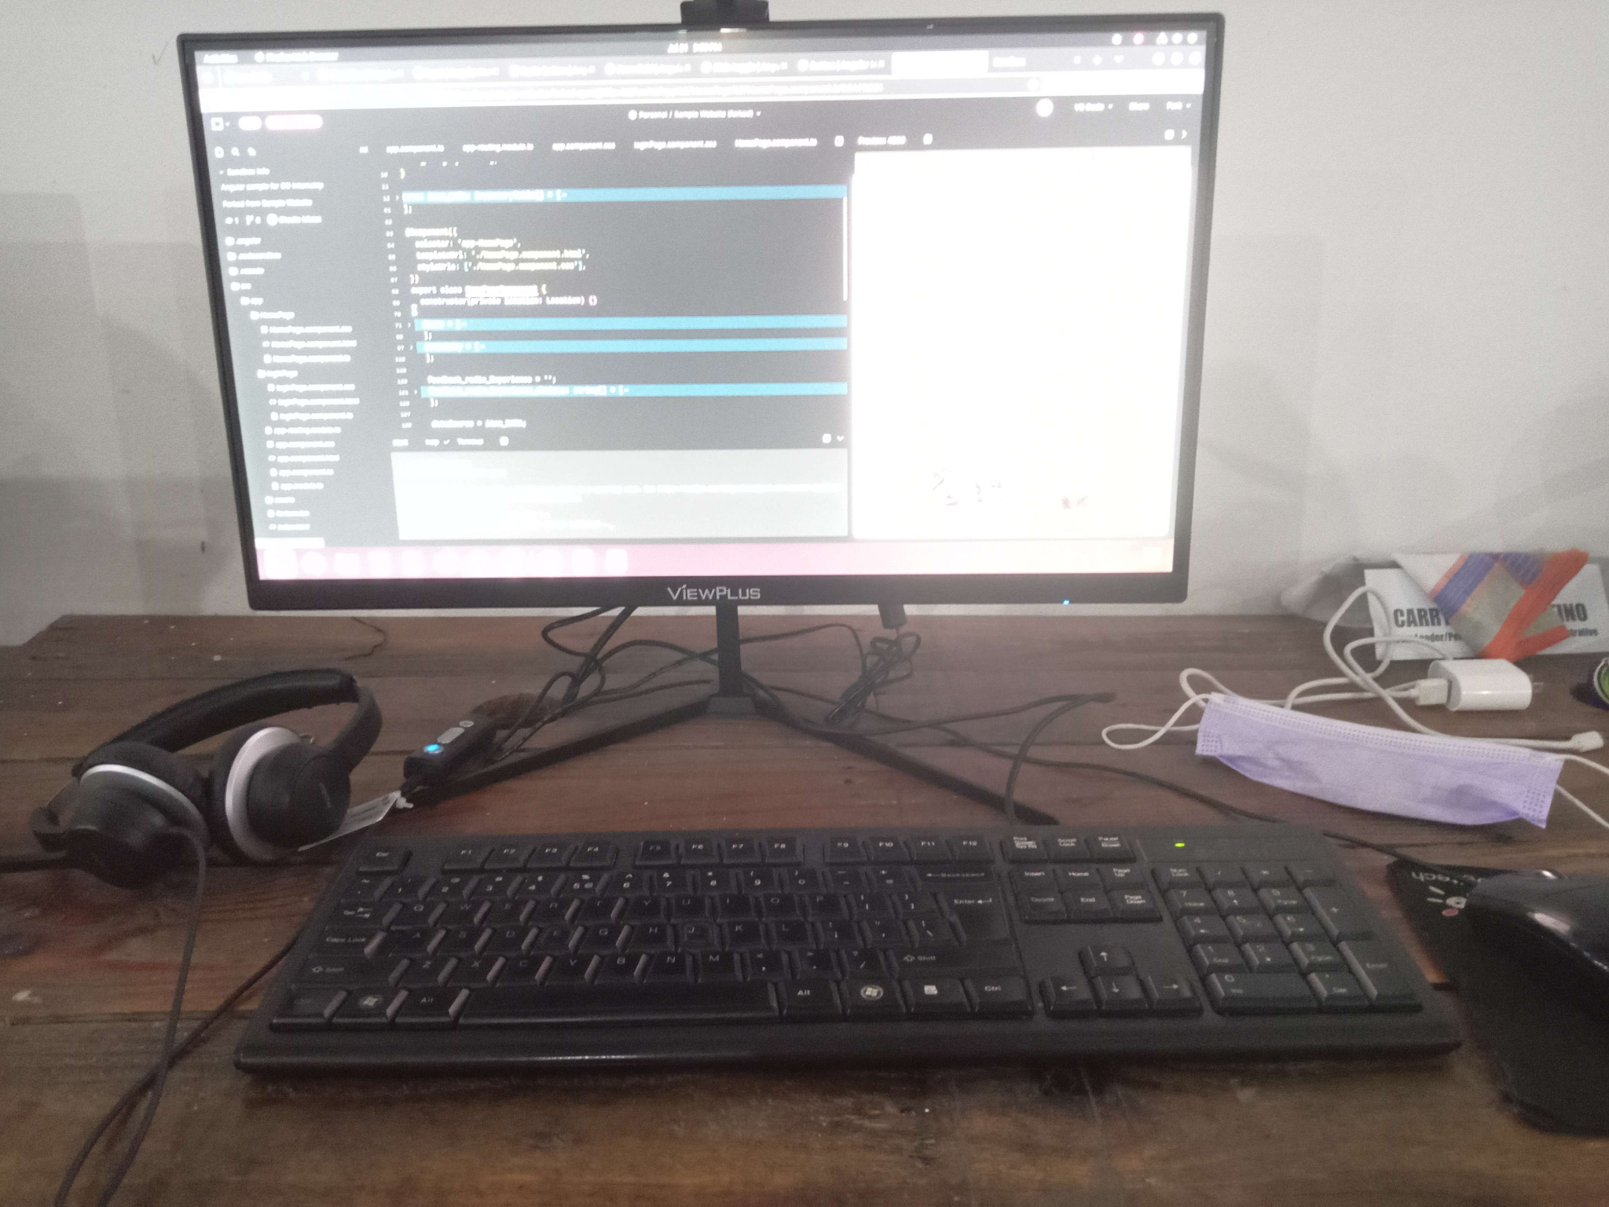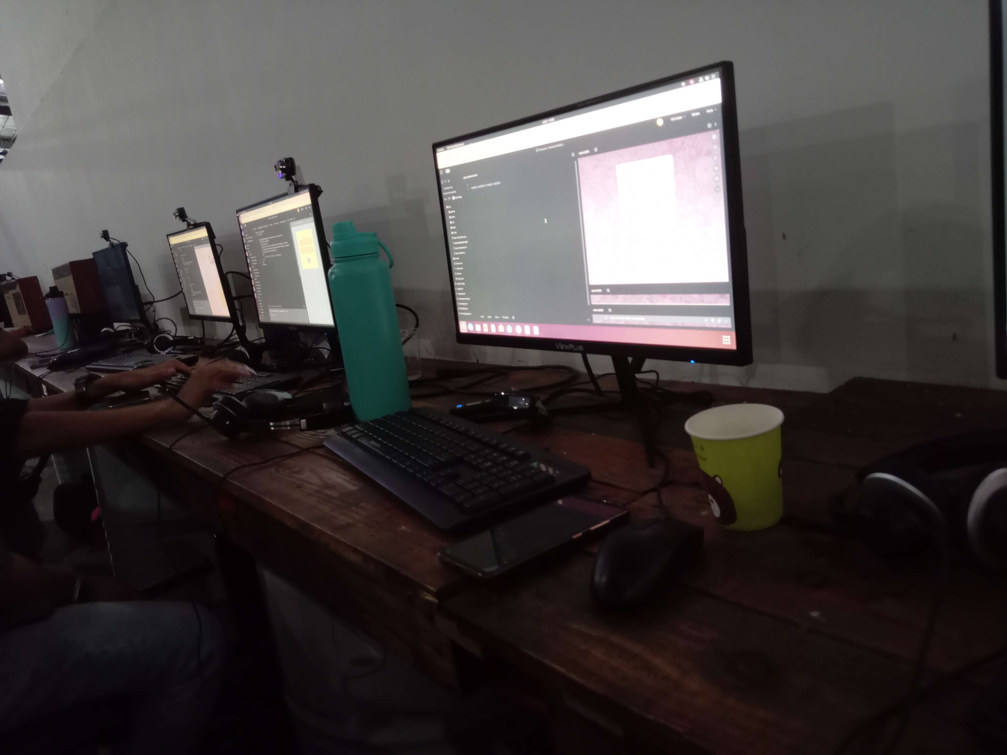

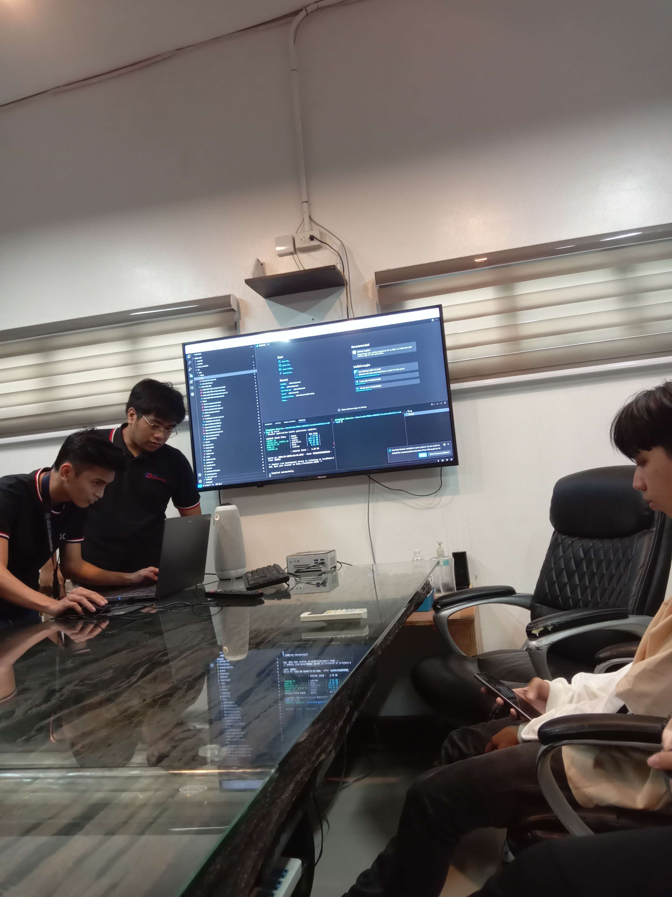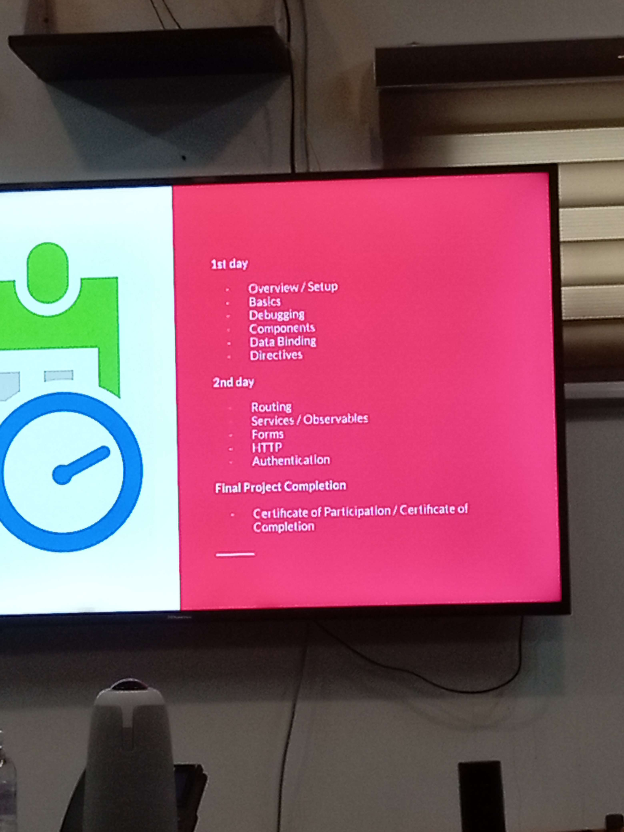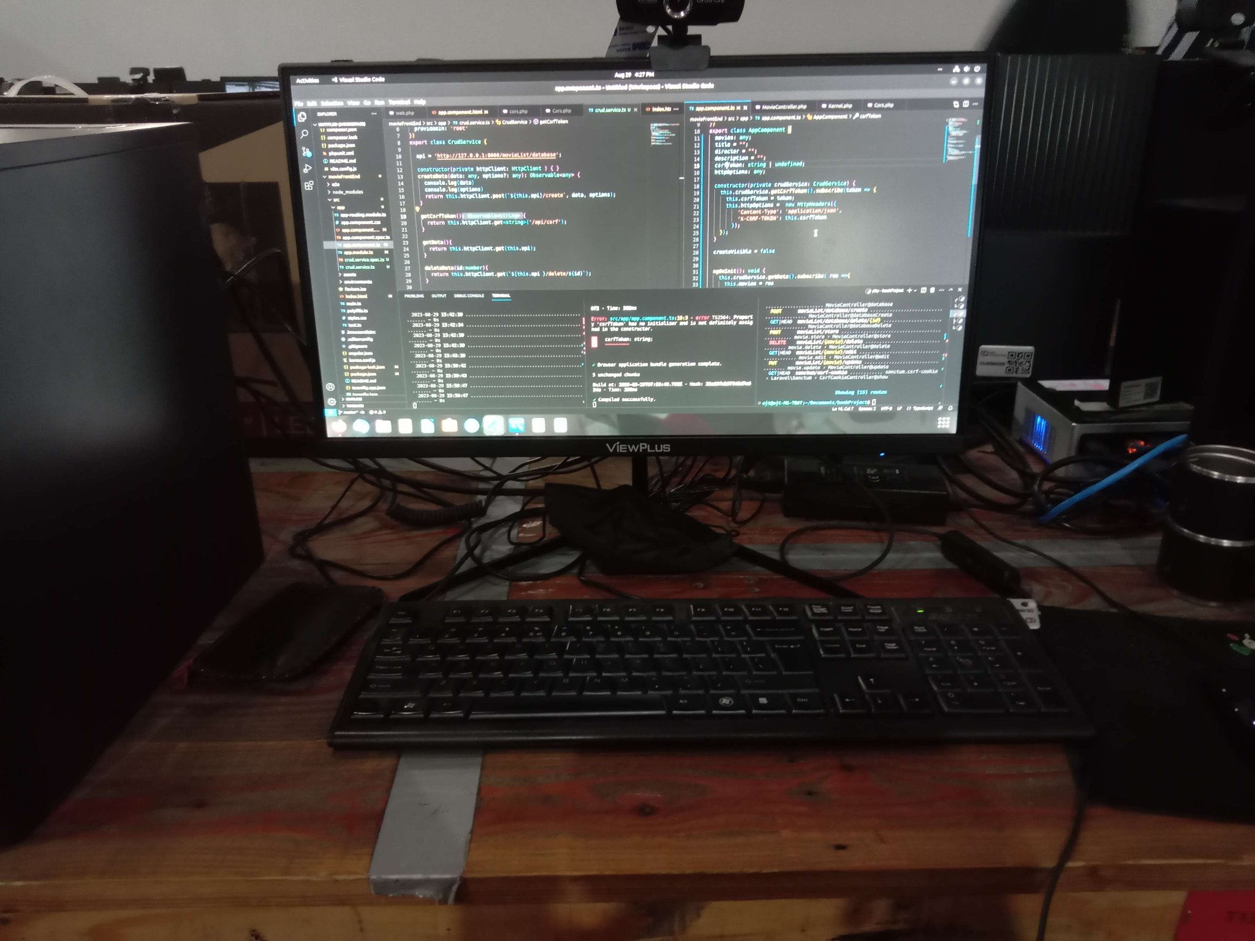

**Observed Organizational Values**

During the internship, I learned that a working relationship is important when accomplishing a task for the company. Of course, teamwork is a related term to this because not everyone can do everything by themselves. I realized this when I couldn’t figure out how to fix a problem in my coding, until I had help from our seniors. With that, the best product is needed to be done with the right effort and coordination. Attendance and Punctuality is also important to always be expected by everyone. In the event that you cannot make it or on time, it’s good to stay professional and let them know and why. Finally, personal grooming means to stay professional at all times, this doesn’t just mean in behavior but also physical appearances. My favorite Bible verse from the weekly journals is from the first week coming from Ephesians 6:7-8 “Serve wholeheartedly, as if you were serving the Lord, not people, because you know that the Lord will reward each one for whatever good they do." This speaks to me not just because it’s my first week and it gave me the best reflection as an advice on what to do for the entire program. It is of course, the most useful viable one for me because indeed, a worker should work hard in serving the company to the best of their abilities, just like how one would serve the Lord. With this, one is rewarded accordingly, and I believe that is a good motivation for one to perform well in their career.**SUMMARY OF WEEKLY HOURS**

|  |  |  |  |
| --- | --- | --- | --- |
| **Date From** | **Date To** | **Number of Hours** | **Remaining Hours** |
| **19-July 2023, Wed** | **21-July 2023, Fri** | **20** | **466** |
| **24-July 2023, Mon** | **28-July 2023, Fri** | **32** | **434** |
| **31-July 2023, Mon** | **4-Aug 2023, Fri** | **29** | **405** |
| **8-Aug 2023, Tue** | **11-Aug 2023, Fri** | **30** | **375** |
| **14-Aug 2023, Mon** | **18-Aug 2023, Fri** | **36** | **339** |
| **21-Aug 2023, Mon** | **25-Aug 2023, Fri** | **32** | **307** |
| **29-Aug 2023, Tue** | **31-Aug 2023, Thu** | **24.5** | **282.5** |
| **4-Sep 2023, Mon** | **8-Sep 2023, Fri** | **35.75** | **246.75** |
| **12-Sep 2023, Tue** | **15-Sep 2023, Fri** | **24.75** | **222** |
| **19-Sep 2023, Tue** | **22-Sep 2023, Fri** | **32.5** | **189.5** |
| **26-Sep 2023, Tue** | **29-Sep 2023, Fri** | **33** | **156.5** |
| **2-Oct 2023, Mon** | **6-Oct 2023, Fri** | **23.75** | **132.75** |
| **9-Oct 2023, Mon** | **13-Oct 2023, Fri** | **28** | **104.75** |
| **16-Oct 2023, Mon** | **20-Oct 2023, Fri** | **47.25** | **57.5** |
| **24-Oct 2023, Tue** | **27-Oct 2023, Fri** | **36.5** | **21** |
| **30-Oct 2023, Mon** | **1-Nov 2023, Wed** | **24** | **-3** |
|  |  |  |  |
|  |  |  |  |



**CHADLE REI M. MICLAT Mr. CHRIS ALMOCERA**

Name & Signature of Student SOC Practicum Coordinator